# CHAPTER 3

**DESIGN**

## Data flow diagram

DFD (data flow diagram) is also known as bubble chart or data flow graph. DFD’s are very useful in understanding the system and can be effectively used during analysis. It shows flow of data through a system visually. The DFD is a hierarchical graphical model of a system the different processing activities or functions that the system performs and the data interchange among these functions. It views a system as a function that transforms the inputs into desired output. Each function is considered as a process that consumes some input data and produces some output data. Function model can be represented using DFD.

[Table 2: Data Flow Diagram Symbols]

|  |  |
| --- | --- |
| **Symbols** | **Description** |
|  | **Entity:** Entities are external to the system  which interacts by inputting the data. |
|  | **System:** It shows the system name. |
|  | **Process:** It shows the part of the system that  transforms into outputs. |
|  | **Data Flow:** It passes the data from one part to  another. |
|  | **Data Store:** Data store is represented by two  parallel lines. It is generally logical file or database. |

**Level 0: Context**

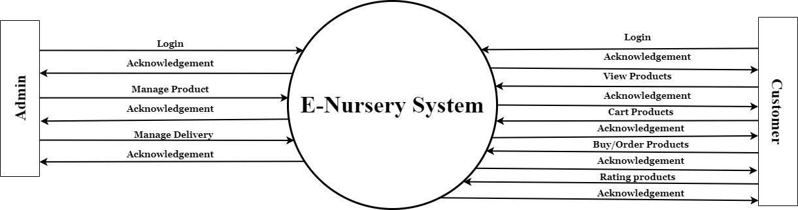

[Figure 2: DFD Context Level]

**Level 1: Admin**

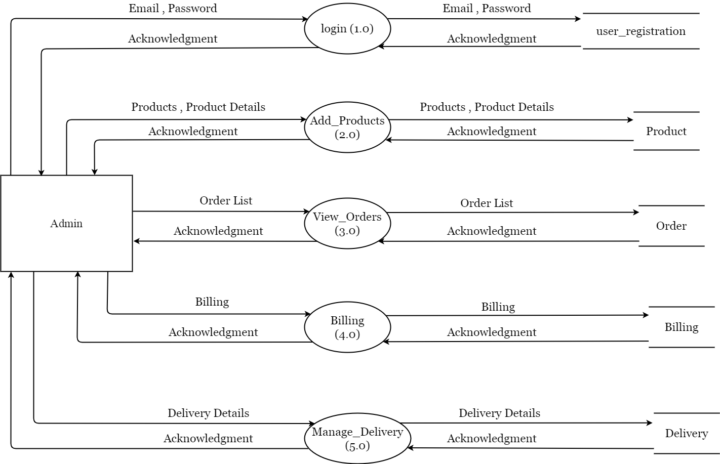

[Figure 3: DFD Level 1: Admin]

**Level 1: Customer**

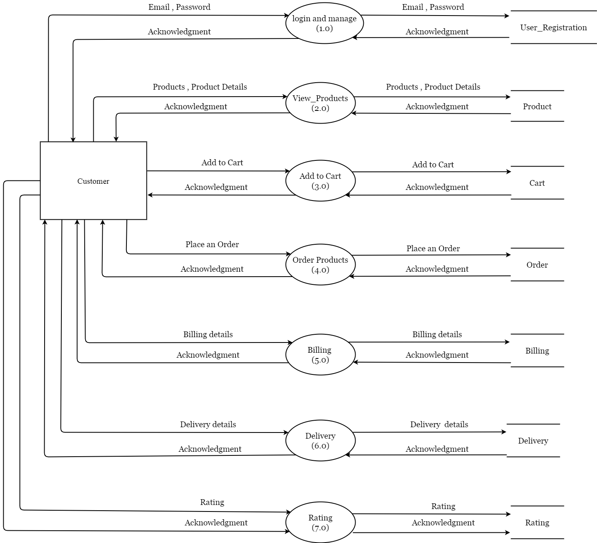

[Figure 4: DFD Level 1: Customer]

## ER-Diagram

An Entity Relationship (ER) Diagram is a type of flowchart that illustrates how “entities” such as people, objects or concepts relate to each other within a system. ER Diagrams are most often used to design or debug relational databases in the fields of software engineering, business information systems, education and research. Also known as ERDs or ER Models, they use a defined set of symbols such as rectangles, diamonds, ovals and connecting lines to depict the interconnectedness of entities, relationships and their attributes. They mirror grammatical structure, with entities as nouns and relationships as verbs.

[Table 3: ER Diagram Symbols]

|  |  |
| --- | --- |
| **Symbols** | **Description** |
|  | **Entity:** Data object is real world  entity or thing. It is represented by a rectangle shape. An entity is an object or concept about which you want to store information. |
|  | **Attributes:** An attribute is property of characteristic of an entity. It is represented by oval shape. |
|  | **Relationship:** Entity are connected  each other via relations. Generally, relationships in binary because there are two entities are related to each other. |
|  | **Cardinality (One to One):** An  instance of entity A can relate to one instances of entity B. |
|  | **Cardinality (One to Many):** An  instance of entity A can relate to one or many instances of B but we can only relate one instance of A. |
|  | **Cardinality (Many to One):** One or more instances of entity A can relate to one instances of B. |
|  | **Cardinality (Many to Many):** One  or more instances of entity A can relate to one more instance of entity B. |

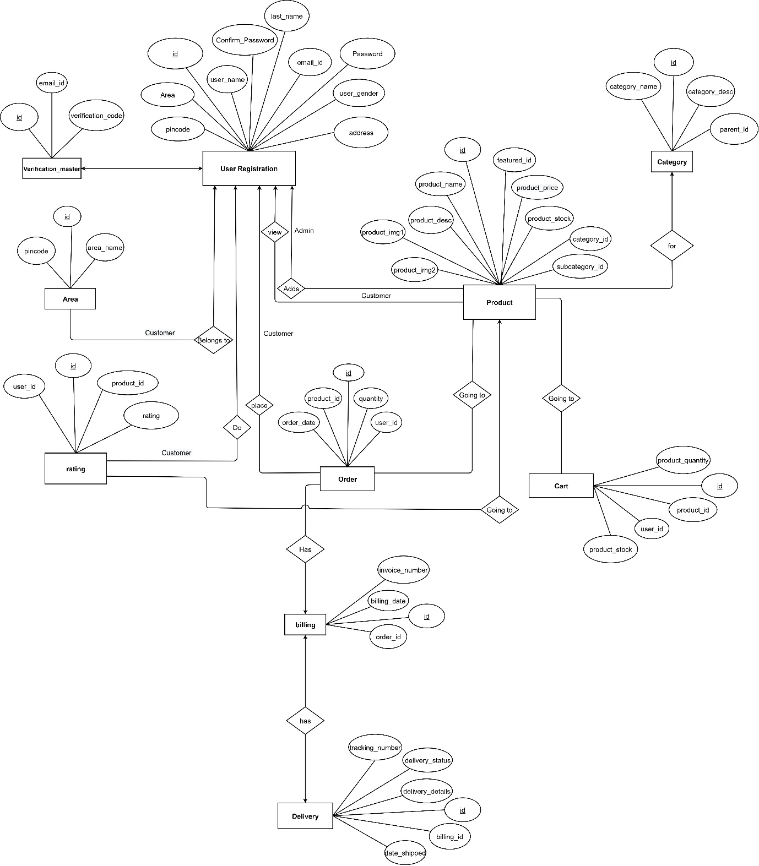

[Figure 5: ER Diagram]